Question 1
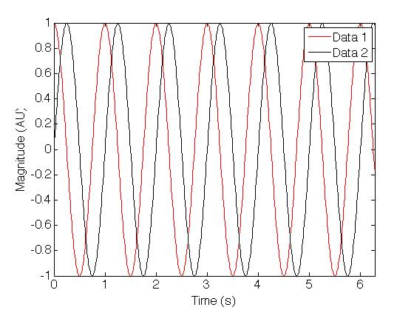
Figure 1: Make sure that your figures are clear, and that axis labels and legends are readable. Be sure to include units on your labels! Using colour in your figures is recommended.

Please use this template for all your assignments. Use Arial (size 12, bold) for headings, Times New Roman (size 12, justified) for text body and references, and Arial (size 10) for figure legends. All margins are 2.54 cm. Place the assignment number and group member names in the header of each page, and page number in the footer (page x of y). Print your assignment single-sided. Please make sure it is stapled or bound—no loose-leaf sheets and no paper clips!

Question 2
Please don’t repeat the question in your answer. Make sure your answer is complete but concise, as there will be a maximum length for each assignment and points will be docked for exceeding this. Don’t forget to refer to your figures (Figure 1) and references (Donelan et al, 2002; Pratap, 2010; Wikipedia: Physiology, 2012).

Question 3
Figures can go anywhere in the text to optimize space. It is probably easiest to embed figures in a text box for formattin g purpose. But, if they are big enough, they can also go on their own sheet (but not many figures will need to be this big). Figure captions can go either below or beside a figure.

References:
- J.M. Donelan, R. Kram and A.D. Kuo. Simultaneous positive and negative external mechanical work in human walking. Journal Of Biomechanics, 35: 117-224, 2002.
- R. Pratap. Getting started with Matlab. New York, Oxford University Press, 2010.
- http://en.wikipedia.org/wiki/Physiology. 10 Sept. 2012.

